

Institute of Engineering & Technology

MID - TERM REPORT

On

Shop Account Analysis

Submitted by
Aniket Singh
171500045
Sanket Kumar
171500292
Rishabh Dev Singh
171500257

Department of Computer Engineering & Applications
Institute of Engineering & Technology



GLA University
Mathura- 281406, INDIA
2019


Department of computer Engineering and Applications
GLA University, Mathura
17 km. Stone NH#2, Mathura-Delhi Road, P.O. – Chaumuha,
Mathura – 281406

Declaration

We hereby declare that the work which is being presented in the Mini project “Shop Account Analysis”, in partial fulfillment of the requirements for project viva voice, is an authentic record of my own work carried under the supervision of our mentor Mr. Piyush Vashishth Sir.

Aniket Singh
171500045
Sanket Kumar
171500292
Rishabh Dev Singh
171500257
B.tech(CSE)
IIIrd Year
Vth Semester

ACKNOWLEDGEMENT

It is indeed with a great pleasure and immense sense of gratitude that we acknowledge the help of these individuals. We are highly indebted to our Mentor Mr. Piyush Vashishth for the facilities provided to accomplish this mini project.
We would like to thank our mentor for this constructive criticism throughout our project.We extremely grateful to our Departmental staff members, Lab technicians and Non-teaching staff members for their extreme help throughout our project.

Finally, we express our heartful thanks to all of our professors who is helping us in thi completion of this project.

ABSTRACT

The purpose of the project entitled as “Shop Account Analysis” is to compute the Office Management of Shops to develop software which is user friendly, fast, and cost – effective. It deals with the collection of Products or items information, diagnosis details, etc. Traditionally, it was done manually. The main function of the system is register and store product details and customer reviews and retrieve these details as and when required, and also to manipulate these details meaningfully. The Shop Account System can be entered using a username and password. It is accessible either by an administrator or owner. Only they can add data into the database. The data can be retrieved easily. The data are well protected for personal use and makes the data processing very fast.

INDEX
1. INTRODUCTION
1.1 Introduction
1.2 Problem introduction
1.3 Modules in the project
2. REQUIREMENTS SPECIFICATION
2.1 Introduction
2.2 Hardware requirements
2.3 Software requirements
3. ANALYSIS
3.1 Existing System
3.2 Feasibility study
3.3 Software specification
4. DESIGN
4.1 System Design
4.1.1 Introduction to UML
4.1.2 UML Diagrams

INTRODUCTION

  - Introduction:
The main objective of the Shop Account Analysis is to manage the details of Stock, Payments, Sales, Discounts,Products. It manages all the information about Stock, Inventory, Products, Stock. The project is totally built at administrative end and thus only the administrator is guaranteed the access.
Once the rates are quoted, the order will be placed with the required delivery schedules. Once the parts the parts are supplied the stocks will be updated. Then a production plan will be drawn up taking the bill of materials into consideration. Once the production plan is approved, the stock will be updated when the material is issued. Once the finished products are available the delivery schedules will be drawn up based on the orders placed by the Customers. The stocks with the dealers will also be maintained.

1.2 Problem Introduction:

Lack of immediate retrievals: -
The information is very difficult to retrieve and to find particular information.
Lack of immediate information storage: -
The information generated by various transactions takes time and efforts to be stored at right place.
Error prone manual calculation: -
Manual calculations are error prone and take a lot of time this may result in incorrect information. For example calculation of customer bill based on various purchasing of items.
Preparation of accurate and prompt billing: -
This becomes a difficult task as information is difficult to collect from various register.

Objective:-
⦁ Define Shops
⦁ Recording information about the Products based on daily basis.
⦁ Recording information related to Customer billing.
⦁ Keeping record of the Products order to Customers.
These are the various jobs that need to be done in a Shop by the owner and Employee. All these works are done on papers.

1.3 MODULES:

- Admin
  - Manage Admin User.
  - Manage Employee.
  - Manage Employee Payroll.
  - Mange Query.
  - Generate Report.
- Customer
  - Request for Registration.
  - Login to Portal.
  - Manage Profile.
  - Send Request and view reply.
  - Send Query and view reply.
  - Give Feedback.

REQUIREMENT SPECIFICATION

2.1 INTRODUCTION:

To be used efficiently, all computer software needs certain hardware components or the other software resources to be present on a computer. These are known as(computer) system requirements and are often used as a guideline as opposed to an absolute rule. Most software defines two sets of system requirements: minimum and recommended. With increasing demand for higher processing power and resources in newer versions of software, system requirements tend to increase over time. Industry analysts suggest that this trend plays a big part in driving upgrades to existing computer systems than technological advancements.

2.2 HARDWARE REQUIREMENTS:

The most common set of requirements defined by any operating system or software application is the physical computer resources, also known as hardware. A hardware requirements list is often accompanied by a hardware compatibility list (HCL), especially in case of operating systems. An HCL lists tested, compatibility and sometimes incompatible hardware devices for a particular operating system or application. The following sub-sections discuss the various aspects of hardware requirements.

HARDWARE REQUIREMENTS FOR PRESENT PROJECT:
PROCESSOR : Intel dual Core ,i3
RAM : 4 GB
HARD DISK : 1TB

2.3 SOFTWARE REQUIREMENTS:

Software Requirements deal with defining software resource requirements that need to be installed on a computer to provide optimal functioning of an application. These requirements or pre-requisites are generally not included in the software installation package and need to be installed separately before the software is installed.

3.ANALYSIS

3.1EXISTING SYSTEM:

Shops currently use a manual system for the management and maintenance of product information. The current system requires numerous paper forms, with data stores spread throughout the shop management infrastructure. Often information is incomplete or does not follow management standards. Forms are often lost in transit between departments requiring a comprehensive auditing process to ensure that no vital information is lost. Multiple copies of the same information exist in the shop and may lead to inconsistencies in data in various data stores..

3.2 FEASIBILITY STUDY

The feasibility of the project is analysed in this phase and business proposal is put forth with a very general plan for the project and some cost estimates. During system analysis the feasibility study of the proposed system is to be carried out. This is to ensure that the proposed system is not a burden to the company. For feasibility analysis, some understanding of the major requirements for the system is essential.

Three key considerations involved in the feasibility analysis are:

3.2.1 Economic Feasibility

This study is carried out to check the economic impact will have on the system will have on the organization. The amount of fund that the company can pour into the research and development of the system is limited. The expenditures must be justified.

3.2.2 Technical Feasibility

This study is carried out to check the technical feasibility, that is,the technical requirements of the system. Any system developed must not have a high demand on the available available technical resources.

3.2.3 Operational Feasibility

The aspect of study is to check the level of acceptance of the system by the user. This includes the process of training the user to use the system efficiently. The user must not feel threatened by the system, instead must accept it as a necessity.

3.3 SOFTWARE SPECIFICATION(languages used)

Front End:
HTML:
HTML defines the structure and layout of a Web document by using a variety of tags and attributes. The correct structure for an HTML document starts with <HTML><HEAD>(enter here what document is about)<BODY> and ends with </BODY></HTML>. All the information you'd like to include in your Web page fits in between the <BODY> and </BODY> tags.

CSS:
Cascading style sheets are used to format the layout of Web pages. They can be used to define text styles, table sizes, and other aspects of Web pages that previously could only be defined in a page's HTML.
CSS helps Web developers create a uniform look across several pages of a Web site. Instead of defining the style of each table and each block of text within a page's HTML, commonly used styles need to be defined only once in a CSS document. Once the style is defined in cascading style sheet, it can be used by any page that references the CSS file. Plus, CSS makes it easy to change styles across several pages at once. For example, a Web developer may want to increase the default text size from 10pt to 12pt for fifty pages of a Web site. If the pages all reference the same style sheet, the text size only needs to be changed on the style sheet and all the pages will show the larger text.

Back End:
Python:
Python is an interpreted, object-oriented programming language similar to PERL, that has gained popularity because of its clear syntax and readability. Python is said to be relatively easy to learn and portable, meaning its statements can be interpreted in a number of operating systems, including UNIX-based systems, Mac OS, MS-DOS, OS/2, and various versions of Microsoft Windows 98. Python was created by Guido van Rossum, a former resident of the Netherlands, whose favorite comedy group at the time was Monty Python's Flying Circus. The source code is freely available and open for modification and reuse. Python has a significant number of users.
Design:

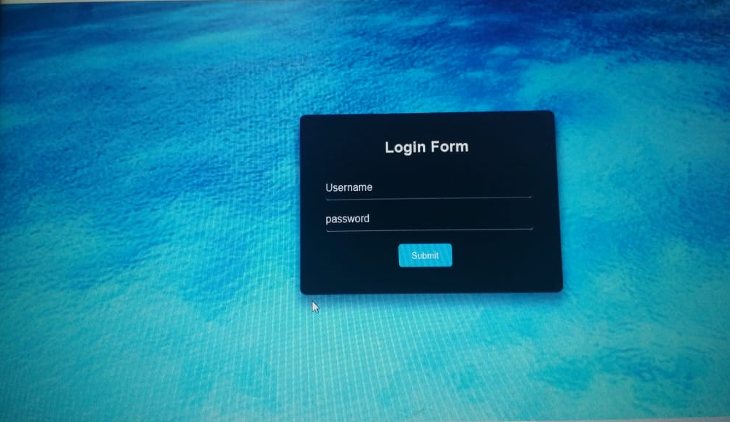
: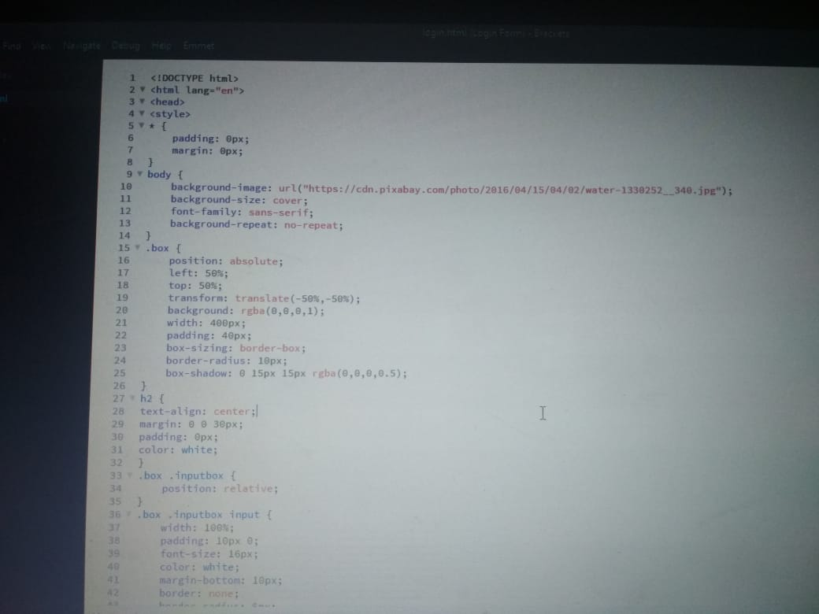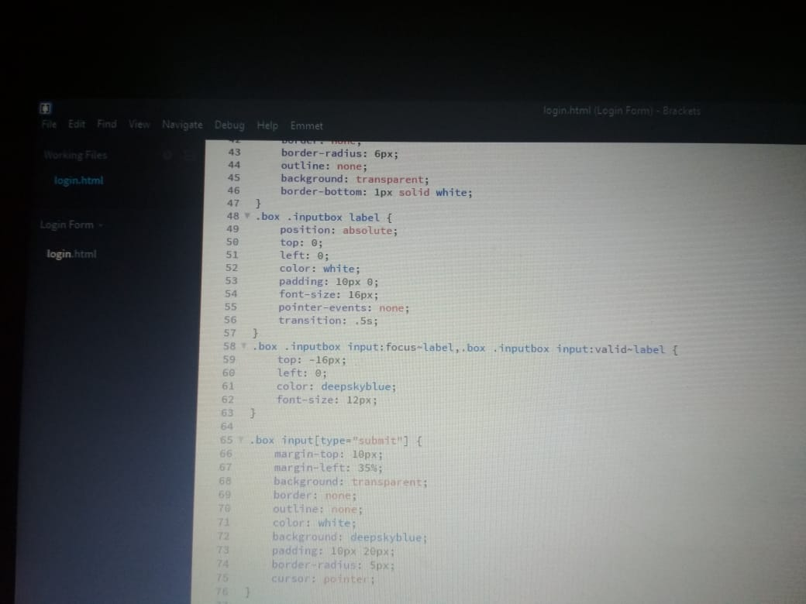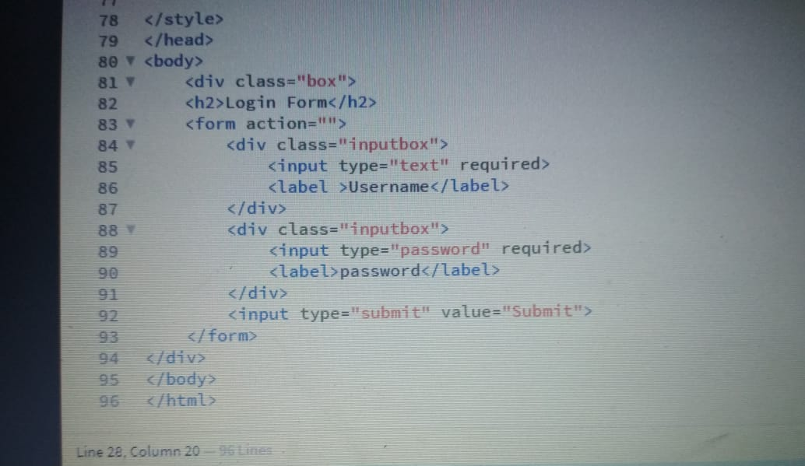

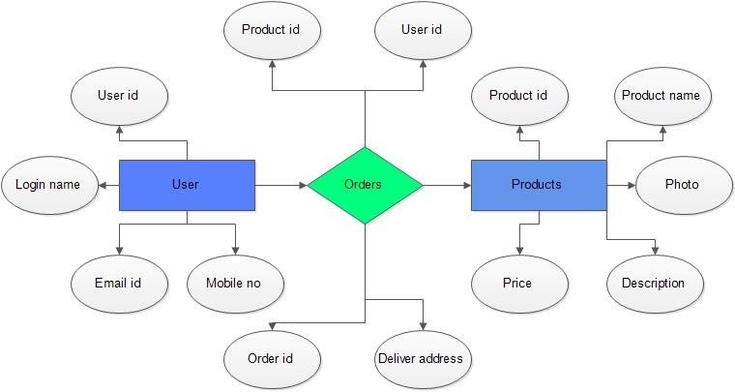
ER-Diagram :

Reference:

- Geeks for geeks
- Stack over flow

